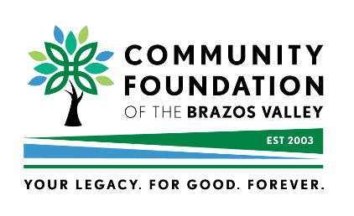

2024 TRIBUTE LUNCHEON
‘Philanthropy’ Sponsor
Saluting Community Philanthropists

John Anderson ∙ Amber and Hunter Goodwin ∙ Lorraine and Chuck Hermann
Tuesday, April 23, 2024 · 11:30 a.m.

Hilton College Station and Conference Center
SPONSORSHIPS

Four sponsorships are available [√ as appropriate]
□ $5,000 'Your Legacy' Sponsor [2 sponsorships - SOLD] – Premiere Seating for
8 including exclusive logo/business name recognition in printed invitation, electronic/website materials, print media, printed program [full-page color advertisement; inside back cover or outside back cover] and thank you recognition in local publications. Forward your company's logo
[NLT February 23] and full-page color ad [NLT March 10] to tributeluncheon@gmail.com.
Please list names of all guests who will be seated at your table [or provide by Friday, April 12]

- _________________________________________________
- ________SOLD-- NOT AVAILABLE______________
- _________________________________________________
- _________________________________________________
- _________________________________________________
- _________________________________________________
- _________________________________________________
- _________________________________________________
□ $2,500 'For Good' Sponsor – premiere seating [for 8] including logo/business name
recognition in printed invitation, electronic/website materials, print media, printed program
[full-page color advertisement; inside back cover or outside cover] and thank you recognition in
local publications. Forward your company's logo [NLT March 10] and 1/2-page ad [NLT March 10] to tributeluncheon@gmail.com. Please list names of all guests who will be seated at your Table
[or provide by Friday, April 12]

- _________________________________________________
- _________________________________________________
- _________________________________________________
- _________________________________________________
- _________________________________________________
- _________________________________________________
- _________________________________________________
- _________________________________________________

OVER

□ $1,500 'Forever' Sponsor - reserved luncheon seating [for 8] including name recognition in invitation, electronic/website materials, printed program, and thank you advertisement.
How would you like to be listed in invitation, program, thank you ad…?
[Example: Mary & John Smith ... or ... ABC Printing] ____________________________________________________
Please list names of all guests who will be seated at your Table [or provide by Friday, April 12]

- _________________________________________________
- _________________________________________________
- _________________________________________________
- _________________________________________________
- _________________________________________________
- _________________________________________________
- _________________________________________________
- _________________________________________________

□ $350 'Community Giving' Sponsor - luncheon reservations for 2 with preferential seating
and special name recognition in the invitation, printed program, and thank you recognition.
How would you like to be listed in publicity?
(Example: Mary & Don Smith .. or ..ABC Printing)________________________________________________________

Please list names of guests for this luncheon sponsorship:

- ____________________________________________________ 2. ___________________________________________________

Sponsor/Business Name: ____________________________________________________________________________

Address:________________________________________________________________________________________________

Phone: __________________________________________ Email: _______________________________________________

NOTE: A formal invitation will follow. Upon receiving this invitation, no further action is required on your part.

PAYMENT OPTIONS:

□ Check for $____________ is enclosed. [payable to Community Foundation]

□ Payment will be forthcoming.
An invoice will be provided, upon request [president@cfbv.org; 979.589.4305]

□ Credit Card #_______________________________ Expiration: ____/____ CVC______

DEADLINE FOR SPONSORSHIPS TO APPEAR IN INVITATION – Friday, February 23
Deadline for luncheon reservations – Friday, April 12– 5:00 p.m.
Return sponsorship form to tributeluncheon@gmail.com
Or mail to: P.O. Box 2622 · Bryan TX 77805-2622
QUESTIONS? 979.589.4305
2.20.2024 FINAL UPDATE

